VC dimension is a theory to illustrate the capability of a hypothesis to classify a thing and number of VC dimensions is a maximum number of data point the hypothesis can shatter.

Shatter means that a hypothesis can completely separate positive and negative data points of a dataset in all possible labels.

The hypothesis is count to be able to shatter if there is even only a single dataset that they can shatter.

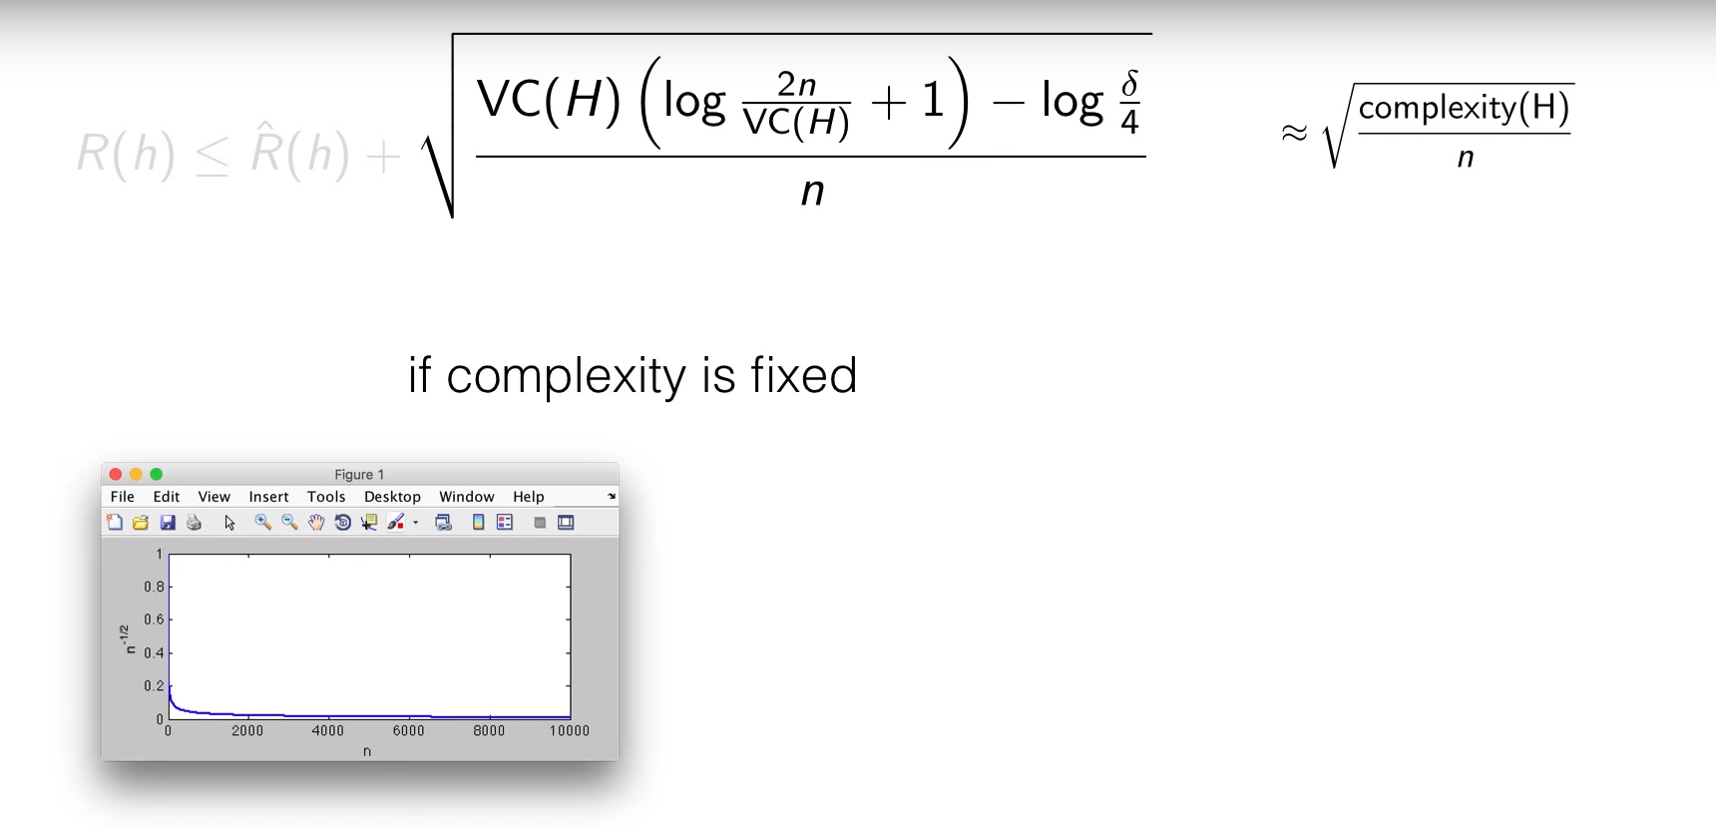

If the complexity is fixed, generalization error reduces as the size of training data increase.

In parametric models, the complexity is fixed and vice versa for non-parametric models.

VC dimension – How many points this model can memorize?

A model class need enough VC dimensions for representing the model.

If a model class have too high VC dimensions, it will memorize the noisy pattern or mistakes from dataset.

Growth Function always less than the break point.

VC dimension

Hoeffding in equality

Shatter

Breakpoint

VC dimension is polynomial

VC inequality

Result of theory

The use of theory

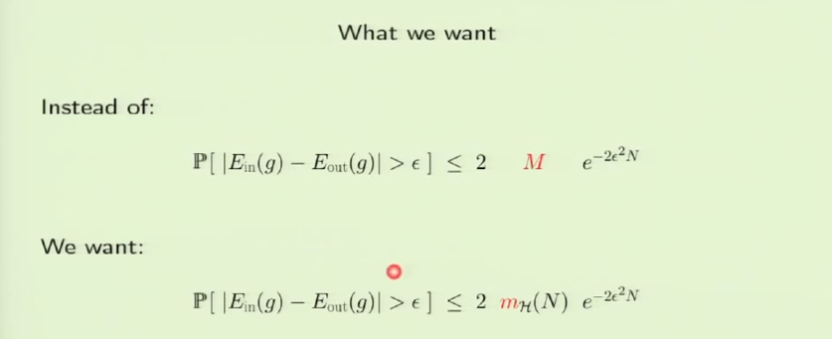

Hoeffding in equality

